### **A CRM Application To Handle The Clients And Their Property Related Requirements**

**Snapshots of Outputs :**

### Create A Jotform And Integrate It With The Org To Create A Record Of Customers Automatically.

**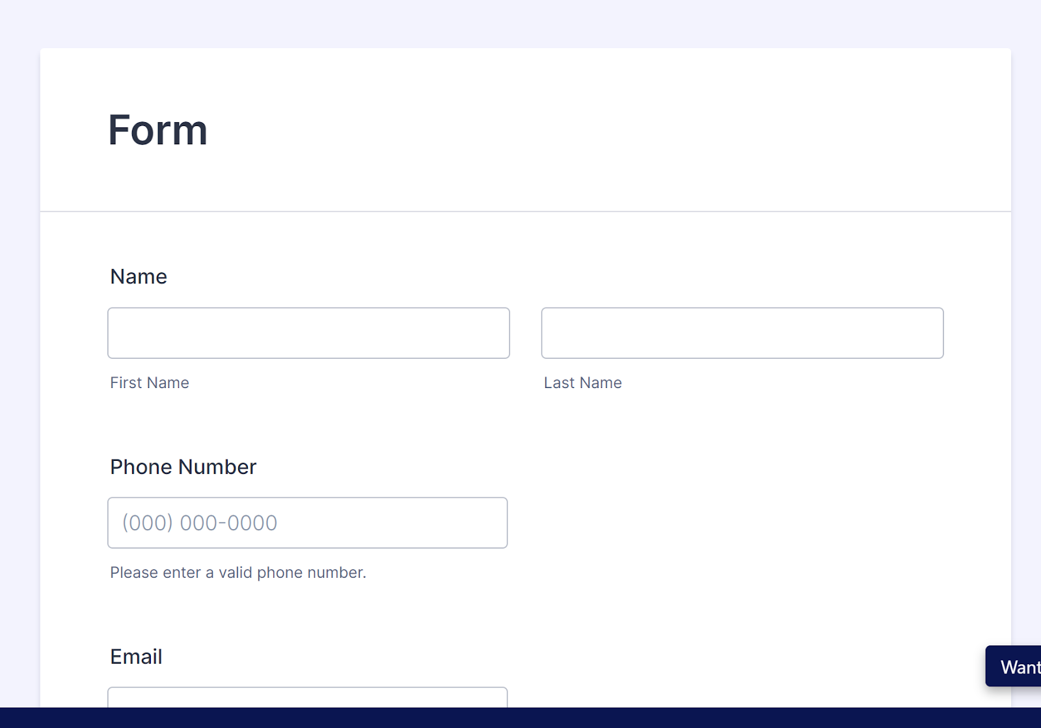**

1. Create Objects From Spreadsheet.

i) Create Customer Object.

**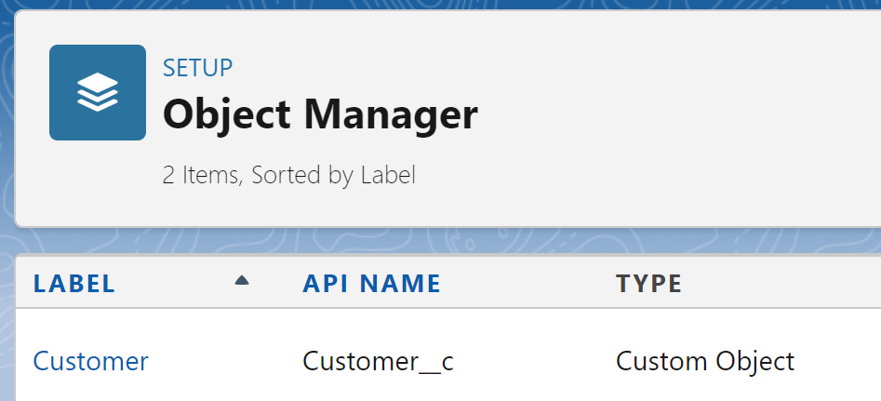**

ii) Create Property Object.

**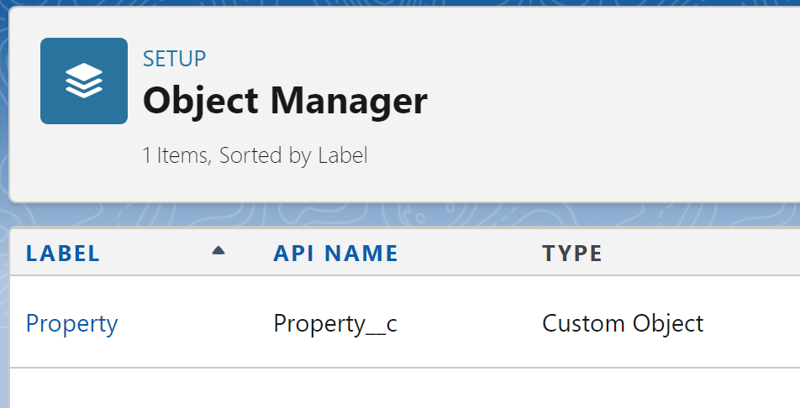**

1. Integrate Jotform With Salesforce Platform.

**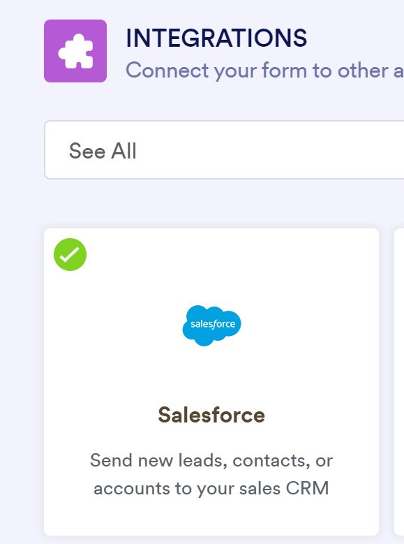**

1. Create Roles.

i) Sales Executive Role.

**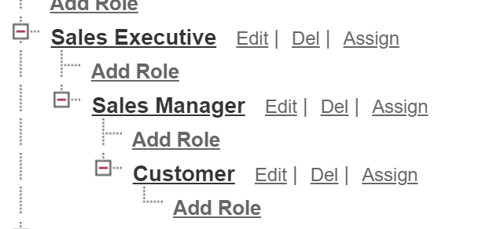**

1. Create A Property Details App.

**IMG_256**

1. Create Profiles.
2. Customer

****

1. Manager

**IMG_256**

1. Create A Check Box Field On User.

****

1. Create Users. (User 1, User 2, User 3, User 4)

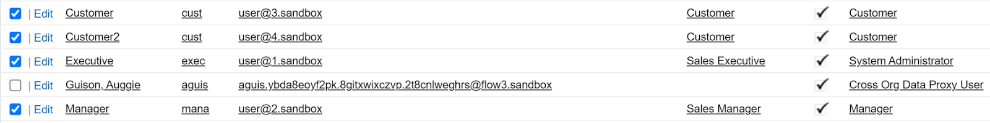

1. Create An Approval Process For Property Object.

**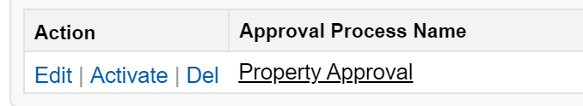**

**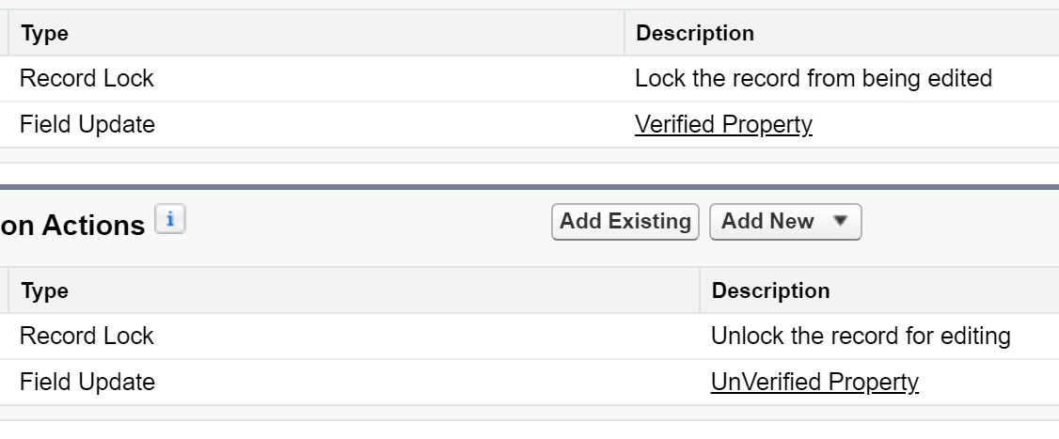**

1. Create A Record Trigger Flow To Submit The Approval Process Automatically.

**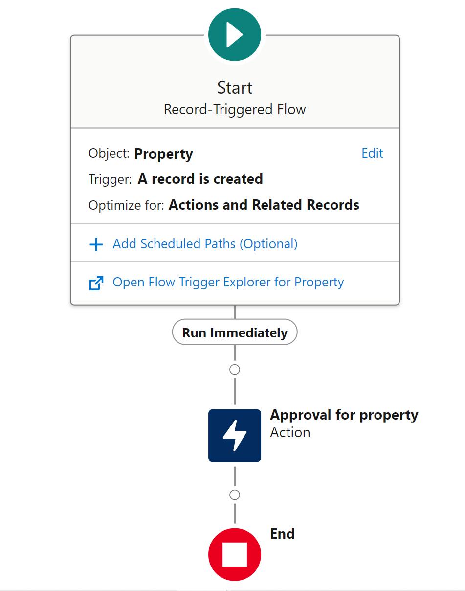**

1. Create An App Page.

**